**UNDERSTANDING THE DATABASE STRUCTURE (PARTS 3.1, 3.2, 3.3, 3.4, & 3.5) –**

1. **How many members/customers does the lemonade stand serve?**

We have a total of 10 members in **tblMembers.**

This number can be accessed by doing

SELECT Count(tblMembers.c_memID_me) As "Number of Customers"

FROM tblMembers;

Which will give us:

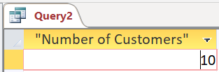

1. **How many flavours of inventory are there? What are the names of the inventory items?**

According to the problem statement, there are total 19 flavours of inventory, as specified in **tblInventory**

The attribute i_stockQty_in is indicative of the quantity of cans of each flavour available in the inventory (0 will imply that the stock is over).

*By doing*

SELECT Count(t_stockDescr_in) As "Total Number of Flavours"

FROM tblInventory

WHERE b_isLemonade_in = True;

We’ll get this:

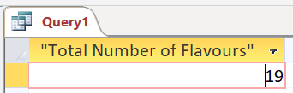

*And by doing*

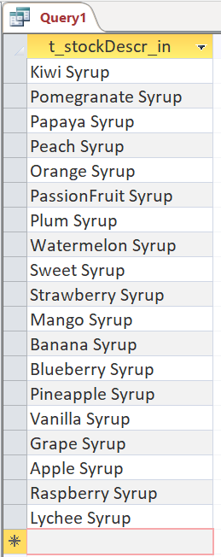SELECT t_stockDescr_in

FROM tblInventory

WHERE b_isLemonade_in = True;

We’ll get all the flavours in the inventory, which are:

1. **Based on the tables, do you think all lemonade sells for the same price? Why?**

No, not all lemonade sells for the same price.

The selling price extremities, as specified in **tblInventory**, and even the final price at which the lemonade flavours are sold, the ones to be entered in **tblInvoice** during the sale of the product, are dependent on numerous variables, including what the cost price for the raw materials were (including the price of the cups and paper towels), how many products the customer is purchasing, whether the customer is a frequent one, etc.

It’d be unfair to have a fixed price for all lemonade, primarily because they serve a numbered customer base over and over again, and it would not be totally incredible to have the customer expect some discount on the premise of loyalty, volumes purchased, etc.

1. **Does the system allow for discounts?**

Yes, the system allows for discounts.

This is being ensured by the fact that the selling price of the products is, along with having a lower and upper cap mentioned in **tblInventory**, is also expected to be entered during sales in **tblInvoice**. This allows for the employees discounting the rates for certain customers as deemed necessary by them (for example, if they are frequent customers or are maybe buying more products), and doesn’t cause any disparity in the records as each sale is recorded on a separate invoice.

The upper and lower cap do ensure that an employee doesn’t drive a business in a loss but also doesn’t inflate the prices too much.

1. **Will the system allow the business to expand to multiple locations?**

Yes, the system will allow the business to expand to multiple locations.

This is ensured by having a separate table - **tblGolfCourse** to take in the information of any new golf courses the business expands to, and assigns them a unique ID number, which can be used as a foreign key by the numerous other tables that make use of (i.e., record) the golf courses the business is being conducted on.